SIMATS ENGINEERING
ASSESSMENT TOOL 2 : Scenario-Based

COURSE NAME: Cloud Computing and Big Data Analytics
COURSE CODE: CSA1508

COURSE OUTCOME COVERED
CO2: Analyze virtualization architectures to identify performance and security issues in cloud computing environments. (BL3)

Dave's Taxonomy: Manipulation (Level 2) Total Marks: 25
Question Count: 5

Code of Conduct
I L.SIVA TEJA(192311073) (Name / Reg No) certify that this submission is my original work and that I have adhered to the guidelines specified for this assessment.
I understand that any violation of academic integrity rules will result in disciplinary action. Signature of the student: L.SIVA TEJA

Assessment Tasks Scenario-Based Questions

- A media company wants to migrate its video streaming platform to the cloud. The system must handle millions of concurrent users with minimal buffering.
Design a cloud architecture using scalability and caching techniques.
Explain how load balancing and auto-scaling can ensure smooth streaming. Discuss cost optimization strategies for such high-demand workloads.
Answer:

Video Streaming Platform Migration

Scenario Understanding
The media company must migrate a video streaming service to the cloud while supporting millions of concurrent viewers with minimal buffering. The core challenges are elastic demand (viewership spikes during peak hours, live events, or popular releases), geographic distribution of users across time zones and continents, very large media file sizes, and the need for consistently low-latency delivery — all while controlling infrastructure cost. Traditional single-datacenter hosting cannot absorb sudden global demand spikes, so the design must treat elasticity and proximity to the user as first-class requirements rather than afterthoughts.
A useful way to frame the problem is to separate it into three planes: the delivery plane (getting bytes to the viewer's device fast), the compute plane (running the business logic — authentication, recommendations, billing), and the storage plane (holding the raw and transcoded video). Each plane has different scaling characteristics and should be architected independently.

Proposed Architecture
- Content Delivery Network (CDN): Cache video segments (encoded in adaptive bitrate formats like HLS/DASH) at edge locations close to users so the vast majority of requests never reach the origin, drastically cutting buffering and origin load.
- Tiered storage: Store master copies in cost-efficient object storage and transcode into multiple resolutions/bitrates; use lifecycle policies to move cold or rarely watched content to cheaper archival tiers.
- Microservices back end: Split the platform into independent services (authentication, catalog, recommendations, billing, streaming session management) deployed on managed compute so each can scale independently based on its own load pattern.
- In-memory/edge caching: Use a caching layer (e.g., Redis) for metadata, session state, and recommendation data to reduce database round trips and speed up page loads.
- Adaptive bitrate streaming: Encode each video in several quality levels so the player can switch dynamically based on the viewer's real-time network conditions, reducing buffering without wasting bandwidth on users with slower connections.
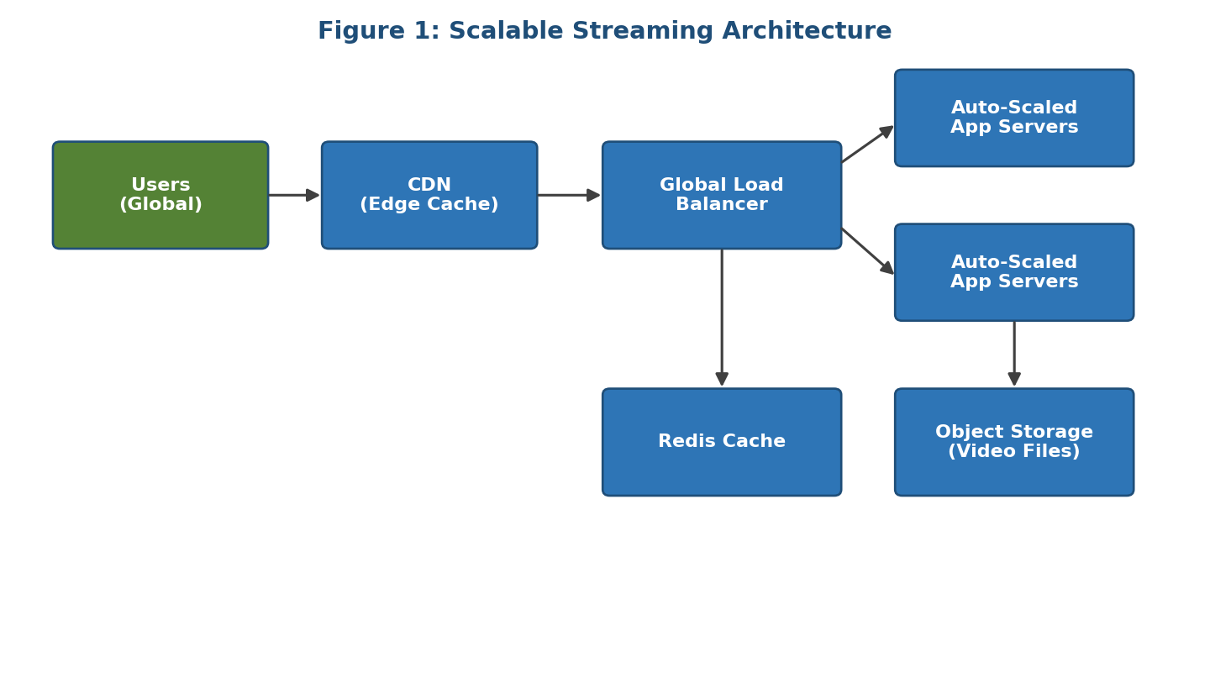
Figure 1: CDN-fronted, auto-scaled streaming architecture with layered caching.

Load Balancing and Auto-Scaling
A global/regional load balancer distributes incoming requests across multiple healthy application instances and across regions, performing continuous health checks to route around failed nodes. Auto-scaling groups monitor metrics such as CPU utilization, request rate, or concurrent connection count and automatically add or remove compute instances to match real-time demand. Combined, these ensure that during a viral spike, new instances spin up behind the load balancer within minutes, keeping response times low without manual intervention, and scale back down afterward to avoid paying for idle capacity. Predictive/scheduled scaling can also be layered on top for known high-demand windows, such as a major sports final or a new season premiere, pre-warming capacity before the surge hits.

Cost Optimization Strategies
- Use a mix of reserved/committed instances for predictable baseline load and spot/preemptible or on-demand instances for burst capacity.
- Maximize CDN cache-hit ratio to minimize expensive origin egress traffic — this is usually the single largest cost lever for a streaming platform.
- Apply video compression and adaptive bitrate streaming to reduce bandwidth consumption per user.
- Use storage tiering and lifecycle rules so infrequently accessed content moves to lower-cost storage classes.
- Continuously monitor cost and usage dashboards to right-size instances and eliminate idle resources.
- Negotiate committed-use or volume discounts with the CDN and cloud provider once traffic patterns stabilize.

Justification / Clarity
This architecture directly addresses the scenario's two stated requirements — massive concurrency and minimal buffering — through horizontal scalability (auto-scaling plus load balancing) and proximity-based delivery (CDN plus edge/in-memory caching), while the layered cost controls keep the solution economically sustainable at high-demand scale. Each design decision maps to a specific bottleneck: the CDN removes origin load, auto-scaling removes capacity ceilings, and tiered storage removes unnecessary storage spend.

- A fintech startup is deploying applications using containers across multiple cloud providers.
They face challenges in maintaining consistency and managing deployments.
Propose a solution using container orchestration and multi-cloud strategies.
Explain how service discovery and scaling can be handled efficiently. Highlight the benefits and risks of a multi-cloud deployment model.
Answer:

Multi-Cloud Container Deployment (Fintech)

Scenario Understanding
The fintech startup runs containerized applications spread across multiple cloud providers and struggles with consistent configuration, deployment, and coordination across these heterogeneous environments — a classic multi-cloud orchestration and consistency problem, compounded by fintech's strict security and regulatory compliance needs (e.g., PCI-DSS, data residency rules). Without a common abstraction layer, teams end up hand-configuring each provider differently, which increases the risk of misconfiguration, security drift, and inconsistent behavior between environments — a serious concern when handling financial transactions.

Proposed Solution: Container Orchestration + Multi-Cloud Strategy
- Kubernetes as a common control plane: Deploy a Kubernetes cluster (or managed Kubernetes service) in each cloud, and use a multi-cluster management layer to apply the same manifests, policies, and RBAC rules everywhere, ensuring configuration consistency regardless of the underlying provider.
- Infrastructure as Code (IaC): Define infrastructure and deployment pipelines using tools such as Terraform, so environments in every cloud are provisioned identically and changes are version-controlled and auditable — important for financial compliance and change-management audits.
- CI/CD pipelines: Standardize build-test-deploy pipelines so the same container image, once built and security-scanned, is promoted across all cloud targets, avoiding drift between providers.
- Service mesh: Introduce a service mesh (e.g., Istio/Linkerd) to standardize secure, mutually-authenticated service-to-service communication, traffic routing, and observability across clusters regardless of underlying cloud.
- Centralized secrets management: Use a cloud-agnostic secrets manager/vault so credentials and API keys are managed consistently and never hard-coded per environment.
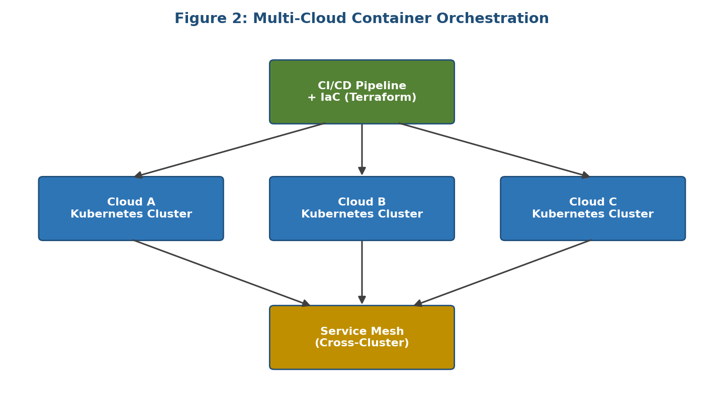
Figure 2: Kubernetes + IaC + service mesh as a common layer across three cloud providers.

Service Discovery and Scaling
Kubernetes-native service discovery (via internal DNS and service objects) lets containers locate each other by logical name rather than IP address, working identically in every cloud. Horizontal Pod Autoscalers scale individual services based on CPU/memory or custom metrics (e.g., transaction volume or queue depth), while cluster autoscalers add or remove worker nodes as pod demand changes — giving consistent, automated elasticity across all providers. The service mesh additionally provides retries, circuit breaking, and traffic-shifting (e.g., canary releases), which matters for a fintech platform where a bad deployment could affect real money movement.

Benefits and Risks of Multi-Cloud
- Benefits: avoids vendor lock-in, improves resilience (a provider-wide outage doesn't take down the whole platform), enables choosing best-of-breed managed services per provider, and can support data-residency or regulatory requirements by hosting specific data in specific jurisdictions/providers.
- Risks: increased operational complexity and broader skill requirements for the engineering team, inconsistent service offerings/APIs between providers, higher networking and egress costs for cross-cloud traffic, a larger security surface that needs unified identity and monitoring, and the overhead of testing and certifying compliance separately for each provider.

Justification / Clarity
Standardizing on Kubernetes plus IaC and a service mesh gives the startup one consistent deployment and security model layered on top of different underlying clouds, directly resolving the stated consistency and deployment-management problem while preserving the flexibility and resilience multi-cloud is meant to provide.

- An e-learning platform experiences data loss due to accidental deletion in the cloud. The organization needs a robust backup and disaster recovery strategy.
Design a solution using cloud-native backup, replication, and versioning.
Explain how recovery time objective (RTO) and recovery point objective (RPO) are achieved. Provide steps to ensure business continuity during failures.
Answer:

Backup and Disaster Recovery (E-Learning Platform)

Scenario Understanding
The e-learning platform suffered data loss from accidental deletion, exposing the absence of a reliable backup and disaster recovery (DR) strategy. The organization needs mechanisms to prevent, detect, and recover from such data-loss events with minimal disruption to students and instructors, who may be relying on the platform for time-sensitive coursework, assignments, or exams. Because deletion (rather than a hardware failure) caused the loss, the design must specifically guard against human error, not just infrastructure failure.

Proposed Solution
- Automated backups: Schedule regular, automated backups of databases and file storage (e.g., daily full backups with incremental/hourly snapshots), stored in a separate storage account or region from production data so a single compromised account cannot destroy both copies.
- Versioning: Enable object/file versioning so every overwrite or delete preserves prior versions, allowing point-in-time recovery of specific files even from an accidental user deletion — this is usually the fastest recovery path for exactly the incident described in the scenario.
- Cross-region replication: Replicate critical data asynchronously to a secondary region so a regional outage or corruption event does not destroy the only copy of the data.
- Soft-delete / retention policies: Configure a grace period (e.g., 30 days) before permanent deletion so accidental deletions can be reversed without restoring from full backup at all.
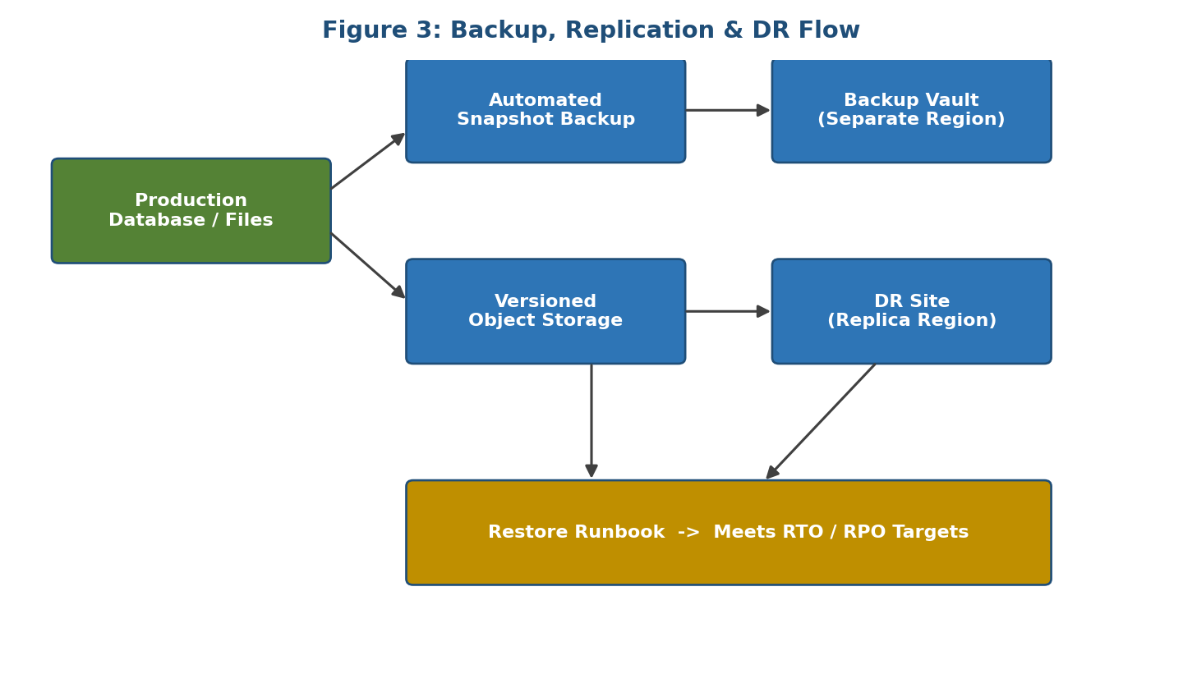
Figure 3: Layered backup, replication, and restore flow with a defined RTO/RPO target.

Recovery Time Objective (RTO) and Recovery Point Objective (RPO)
Recovery Point Objective (RPO) — the maximum tolerable data loss, measured in time — is achieved by shortening the interval between backups/replication events (e.g., near-continuous replication yields an RPO of minutes rather than a day). Recovery Time Objective (RTO) — how quickly service must be restored after an incident — is achieved by maintaining warm/standby infrastructure or automated restore scripts and runbooks so recovery is a matter of triggering a tested procedure rather than manually reconstructing systems. The organization should define target RPO/RTO values (for example, an RPO of 15 minutes and an RTO of 1 hour) based on how critical the platform is to academic operations, then design backup frequency and standby capacity specifically to meet those targets.

Steps to Ensure Business Continuity
- Classify data by criticality (e.g., grades and submissions vs. static course material) and apply an appropriate backup frequency to each class.
- Regularly test restore procedures — not just backup creation — to confirm backups are actually recoverable within the target RTO.
- Maintain a documented, rehearsed DR runbook with clear roles, communication plans, and escalation paths.
- Monitor backup jobs continuously and alert immediately on any failure.
- Apply least-privilege access and deletion safeguards (e.g., multi-person approval for bulk deletes) to reduce the chance of the incident recurring.

Justification / Clarity
Combining versioning, automated backups, and cross-region replication gives multiple independent layers of protection, so recovery from an accidental deletion becomes a fast, low-impact restore rather than permanent data loss — directly meeting the scenario's requirement for a robust backup and DR strategy while also satisfying broader continuity needs.

- A government agency is adopting a hybrid cloud model for sensitive and non-sensitive data. Some applications must remain on-premises due to compliance requirements.
Design a hybrid architecture that ensures secure communication between environments.
Explain how identity management and encryption should be implemented. Discuss challenges in managing hybrid cloud environments.
Answer:

Hybrid Cloud for a Government Agency

Scenario Understanding
The agency must handle both sensitive data (which compliance rules require to remain on-premises) and non-sensitive workloads that can benefit from cloud scalability and cost efficiency. This calls for a hybrid cloud architecture that securely bridges the two environments while strictly respecting regulatory boundaries. Unlike a purely commercial migration, the design constraint here is not primarily technical but regulatory: certain data must never leave the on-premises boundary, which shapes every downstream architectural decision.

Proposed Hybrid Architecture
- Workload segregation: Keep regulated/sensitive data and the applications that process it on-premises or in a private cloud, while non-sensitive, public-facing, or burstable workloads (e.g., a public information portal) run in the public cloud.
- Secure connectivity: Establish a dedicated private link (e.g., a site-to-site VPN or a direct/express interconnect) between the on-premises data center and the cloud provider, rather than relying on the public internet, to secure data in transit and provide predictable performance.
- API gateway / integration layer: Expose only well-defined, authenticated, and rate-limited APIs between environments so cloud applications can request non-sensitive, aggregated data without ever having direct access to sensitive on-premises data stores.
- Consistent management plane: Use hybrid cloud management tooling to apply uniform monitoring, patching, and policy enforcement across both environments so security posture doesn't silently diverge over time.
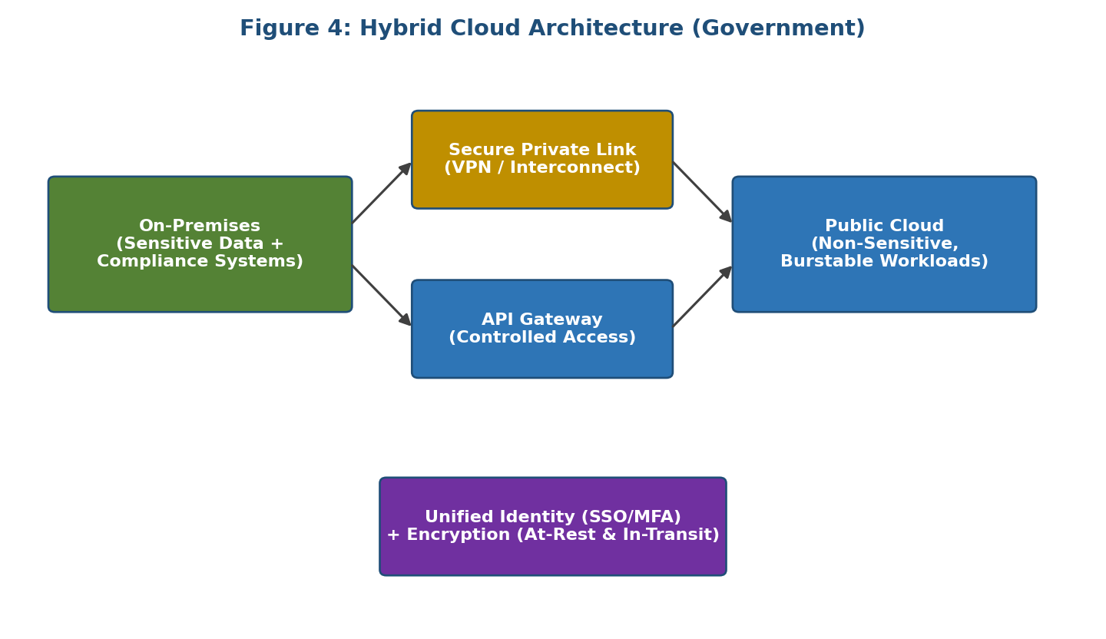
Figure 4: Segregated hybrid architecture with a controlled link, unified identity, and encryption.

Identity Management and Encryption
A unified identity provider (using standards such as SAML or OAuth with single sign-on and multi-factor authentication) should govern access across both on-premises and cloud resources, with role-based access control enforcing least privilege for every user and service account. Encryption should be applied at rest (using strong algorithms with keys managed via a hardware security module or a cloud key-management service) and in transit (TLS for all cross-environment traffic), with sensitive data additionally tokenized or masked before any transfer to cloud-hosted components — so that even the aggregated data leaving the boundary cannot be traced back to an individual record.

Challenges in Managing Hybrid Cloud
- Maintaining consistent security policies and configurations across two fundamentally different operational models.
- Network latency and reliability of the on-premises-to-cloud link for workloads with tight interdependencies.
- Data governance complexity — knowing exactly where each data element resides at all times and ensuring it never crosses into a non-compliant environment, even transiently.
- Skill and tooling overhead of operating two distinct infrastructure paradigms simultaneously.
- Auditing and compliance reporting across a distributed environment, which regulators will scrutinize closely.

Justification / Clarity
Segregating workloads by sensitivity, connecting environments through a controlled private link, and enforcing unified identity and encryption directly satisfies the compliance requirement to keep sensitive data on-premises while still allowing the agency to gain cloud scalability and cost benefits for non-sensitive workloads.

- A SaaS provider needs to ensure high availability and fault tolerance for its application.
The system must continue operating even if one region goes down.
Propose a multi-region deployment strategy in the cloud.
Explain how data replication and failover mechanisms should be configured. Discuss monitoring and alerting strategies for proactive issue detection.

High Availability for a SaaS Application

Scenario Understanding
The SaaS provider needs the application to remain available and fault-tolerant even if an entire cloud region fails. This requires an architecture that spans multiple regions with automatic failover, rather than relying on a single region or point of failure. For a SaaS product serving multiple customers under contractual uptime commitments (SLAs), a regional outage that takes down the whole service is not just a technical issue but a business and reputational one, so the design must treat cross-region resilience as a core requirement.

Multi-Region Deployment Strategy
- Active-active or active-passive regions: Deploy full application stacks in at least two geographically separate regions. In active-active mode both regions serve live traffic simultaneously (maximizing resource use and reducing latency for users near each region); in active-passive mode a standby region is kept warm and ready to take over on demand.
- Global traffic routing: Use a global load balancer or DNS-based routing with health checks to direct users to the nearest healthy region and automatically reroute traffic away from a failed region within seconds to minutes.
- Stateless application tier: Design application servers to be stateless (session data stored externally, e.g., in a distributed cache) so any instance in any region can serve any request, which greatly simplifies failover.
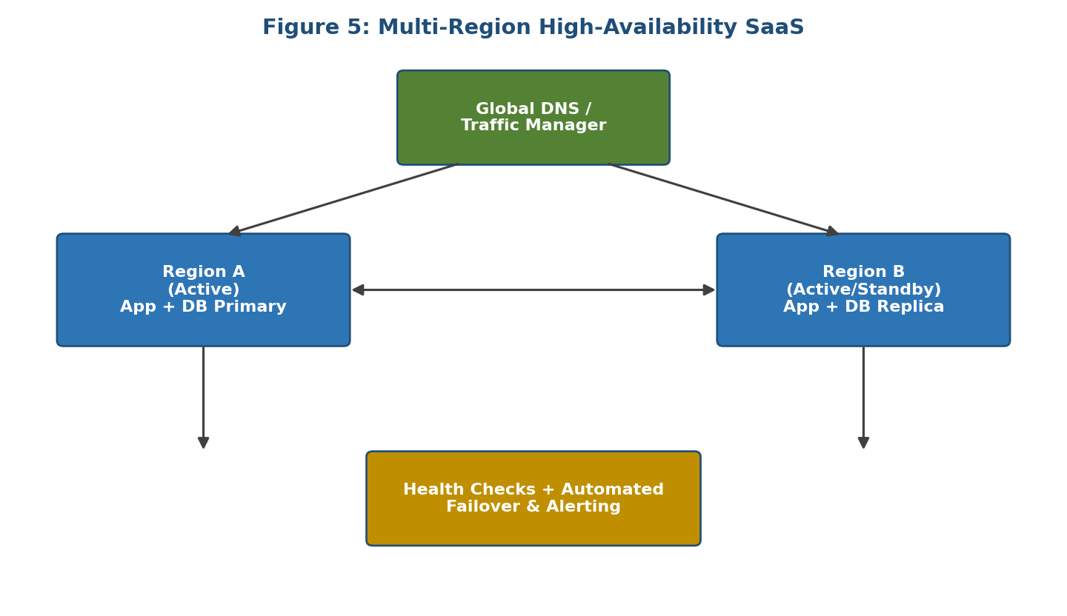
Figure 5: Active/standby multi-region deployment with global routing and automated failover.

Data Replication and Failover
The database layer should use synchronous replication within a region (for zero data loss on a local node failure) and asynchronous replication across regions (to avoid the latency penalty of synchronous cross-region writes, accepting a small, bounded RPO). Automated failover mechanisms should detect a region outage via health checks and promote the replica in the healthy region to primary, updating routing so traffic transparently shifts with minimal downtime. Failover procedures should be tested regularly through planned exercises (sometimes called game days) to confirm they actually work under realistic failure conditions rather than only on paper.

Monitoring and Alerting
- Implement real-time health checks and synthetic transaction monitoring at each region and endpoint to detect problems before customers notice.
- Track key service-level objectives (latency, error rate, availability) with dashboards and automated alerts routed to an on-call team.
- Use distributed tracing and centralized logging across regions to quickly pinpoint the failing component during an incident.
- Set up anomaly detection to catch early warning signs, such as rising error rates or replication lag, before a full regional outage occurs.

Justification / Clarity
Spreading the application and its data across multiple regions with automated, health-check-driven failover ensures that the loss of any single region does not interrupt service for customers, directly meeting the scenario's requirement for high availability and fault tolerance while providing measurable, testable recovery guarantees.

Scenario-Based Rubric

Criteria | Weightage | Level 4 -  Exemplary | Level 3 -  Proficient | Level 2 -  Developing | Level 1 -  Beginning
Understanding of Scenario | 20% | Demonstrates complete understanding of the scenario context | Good understanding with minor gaps | Partial understanding | Fails to understand the scenario
Identification of Risks / Issues | 20% | Identifies all major issues correctly | Identifies most issues | Limited issue identification | Misses major issues
Application of Concepts | 25% | Applies virtualization concepts effectively | Applies concepts with minor mistakes | Partially correct application | Weak  application
Decision  Justification | 20% | Decisions are well justified and technically strong | Reasonable  justification | Weak  justification | No useful justification
Clarity | 15% | Clear and well-organized response | Generally clear | Somewhat  unclear | Poorly presented

